**How to find any percentile**

Find 38th percentile, n = 11.

|  |  |  |  |  |  |  |  |  |  |  |
| --- | --- | --- | --- | --- | --- | --- | --- | --- | --- | --- |
| 16.4 | 16.4 | 28.2 | 31.5 | 34.1 | 36.6 | 40.4 | 45 | 76.7 | 77.7 | 109.9 |

$$\tilde{x}= 36.6$$

P% = (P/100)*n = (.38)(11)

= 4.18

Index(4) + .18(Index(4+1)-Index(4))

$$=31.5 + .18\left(34.1-31.5\right)=31.96$$

* **Mean $\overline{x}$ or $u$** 
  + 1000,8,7,9,4 => $\overline{x}= 6.6$
$\overline{x}= 205.6$

* **Median $\tilde{x}$** (if n is odd, then $\tilde{x}$ is the middle number)
  + $\overline{x}$ = $\frac{∑x}{n} or M=\frac{∑x}{N}$
 $\tilde{x}$

 + 4,7,8,9,1000
    - (8+9) / 2 = 8.5

When you have normal distribution, then $\overline{x}$ = $\tilde{x}$

When $\overline{x}>\tilde{x }$ skewed to right (Mean greater than median)

* "Positively skewed"

When $\overline{x}<\overline{x}$ skewed to left (Mean less than median)

* "Negatively skewed"
* **Shortcut for standard deviation**
* **Take square root of this :**

$S^{2}=\frac{\sum{x^{2}}-\frac{{\left(\sum{x}\right)}^{2}}{n}}{n-1}$

$S=\sqrt{S^{2}}$

**Variance , S2 =**  Variance for population : $σ^{2}=\frac{\sum{{\left(x-u\right)}^{2}}}{N}$

$$∑\left(x-\overline{x}\right)$$

Sample size of 5

$X1 –\overline{x} = 4$

$$X2 - \overline{x}= -8$$

$$X3 – \overline{x}= -2$$

$$X4 – \overline{x}= 0$$

$$X5 – \overline{x}= \left(NOT GIVEN\right)$$

$$Find S.V.$$

$∑\left(x-\overline{x}\right)=$ ­

0

$$X5 - \overline{x}= 6$$

Use variance equation = 30

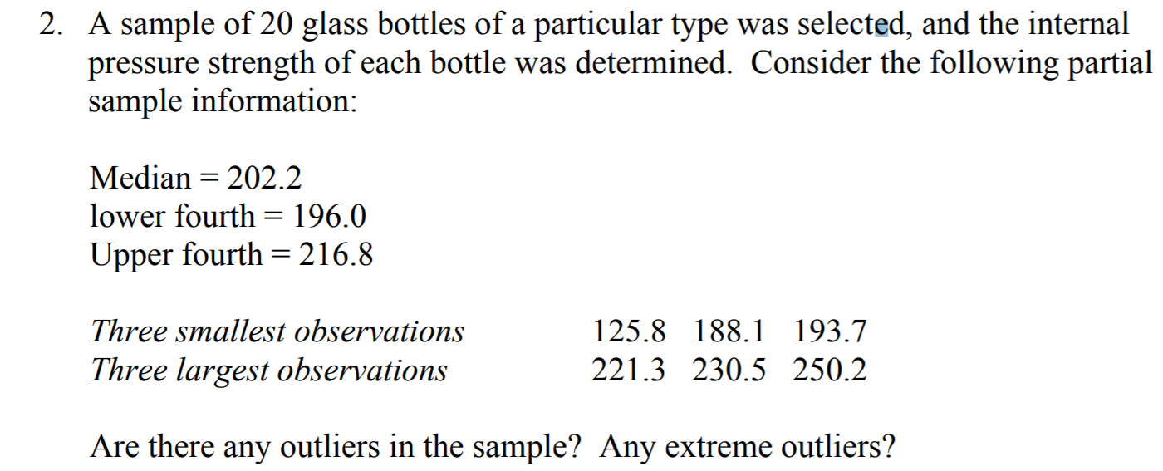

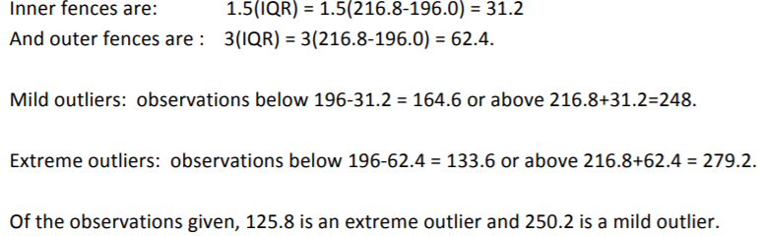

Chebyshev’s Rule

Minimal Spread = $1 -\frac{1}{k^{2}}$

K = no. of + and – std. dev from the mean

